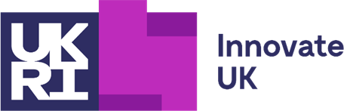

Meeting of the Innovate UK Council
Thursday 3rd March 2022
Summary of meeting

Council members were welcomed to the meeting. The minutes of the previous meeting, held on December 15th, were deemed accurate and approved.

Operational Update

The Innovate UK Senior Leadership team each gave an update on their respective areas. Recent top-level organisational changes, and the importance of the Levelling Up agenda were emphasised. Uncertainty surrounding Horizon Europe and association persists.

Updates were given on Challenge fund commitments, SR Allocation processes, co-investment, and Faraday Phase Two. The digital reach of Innovate UK’s social media channels was demonstrated, followed by an update on the future Shopfront, this included a visual demonstration of the funding finder tool. Council heard about the new funding assurance tool, EDI actions and evolution of the SMART program, as well as the transition to Innovate UK KTN.

Innovating Innovate UK/Future Economy Review/Plan for Action

Likely funding allocations, in the context of Innovate UK’s Plan for Action and UKRI Strategy were reviewed. Council was pleased with the plans to work in partnership with UKRI colleagues in delivering the Plan for Action. An update on the Catapult ‘New Deal’, which has garnered full support from the Secretary of State and BEIS, was given.

Council Sub-committees

Ways of evolving our current governance structure, including involving Council members in sub-committees, was discussed.

Levelling Up Place and Innovation

A presentation on Innovate’s response to the levelling up white papers was given. Included in this was the organisational restructuring and political context of R&D investment.

EDI Strategy

Council received an overview of Innovate UK’s EDI priorities, work to date and the future No Limits program. Council was very pleased with progress. The importance of EDI as a central objective for Innovate UK, being transparent about our internal diversity and structures was also emphasised.

Forward Look

An indicative forward looks on governance, Innovating Innovate UK, and themes for future Council meetings was presented.

Closed Council session

A closed session was held initially with the CEO and then for Council members only.

The formal minutes of this meeting will be approved at the Innovate UK Council meeting on June 9th, 2022.

