Access to High Performance Computing:
Tier-2 Technical Assessment Form

Instructions:
- Complete Section 1 below as fully as possible. If you have any questions or require clarification, please contact the centre which you would like to apply for resources on. Contact details for each centre can be found in Appendix 1 of the Access to HPC call document.
- Return the completed form (as a Word document) to the centre which you are applying to by using the appropriate contact identified in the bullet point list above along with a short project description.
- The Tier-2 team will complete Section 2 and will contact you directly for more information if it is required. This may take up to 10 days from receipt of the completed form.
- The Tier-2 team will return the fully completed form to you so you can include it in your application.

Notes for Applications:
- Each service may specific restrictions on the form of the applications it accepts. Details on these can be found in Appendix 1 of the Access to HPC call document.
- Applicants should supply quantitative evidence that the codes to be used scale to cpu/gpu/node counts requested. Details on the evidence required can be found in Section 1, Part 6. Please note this section is not mandatory for Tier-2 systems that have novel architectures.

Section 1: HPC Resources and Case for Support
(To be completed by the applicant)

- Project Information.

  - Project Title: [Enter project title]
  - Tier-2 Centre applying to: [Cirrus/CSD3/ HPC Midlands+/Isambard/JADE/NI-HPC/NICE]

  - PI Name and Contact Details.

Name: | [Please Complete Table]
Department:
Institution:
Position Held:
Address:
Postcode:
e-Mail:
Telephone:
Nationality:

  - Contact details for application (if different from PI above)

Name: | [Please Complete Table]
Department:
Institution:
Position Held:
Address:
Postcode:
e-Mail:
Telephone:
Nationality:

  - Proposed start date of Tier-2 use: [Enter start date]

  - Project length (months) of Tier-2 use: [Enter project length]
  - Brief Project Summary

[Please insert a brief and high level description of the aim of your computational project/work, keeping within the space provided on this page]

- Previous Use of HPC Resources.

  - Which other HPC services have you used?

[Enter list of other HPC services]

- If you have used other HPC services please provide a brief summary of the core/GPU/KNL node hours used (as appropriate) and the types of jobs run (codes, core/GPU/KNL node counts, typical job lengths):

[Enter summary of previous service usage]

- Tier-2 Software and Support Requirements.
  - Summary of software requirements.

What are the main codes you will be using?

[Enter list of codes with links to descriptions if possible]

Software requirements (e.g. compilers, libraries, tools):
Please note that Tier-2 centres will expect users to build their own software but will provide support where possible. A selection of commonly used software will be maintained centrally.

[Enter list of software requirements to support your use of the Tier-2 resource]

Support Requirements
How do you plan to port and optimize your code on Tier-2?

[Enter text about how you will port and optimize your code]

Please summarise any other support requirements for this project:

[Enter any other support requirements]
- Proposed Use of Tier-2 Resources.

  - Job size mix for the project
Please see notes at beginning of this document regarding the maximum amounts of time that can be applied for and consult any call guidelines.

 | Largest Job | Typical Job | Smallest Job
Number of nodes | [Please Complete Table]
Number of cores/GPUs used per node
Wallclock time for each job*
Number of jobs of this type
Memory per node required.

*The maximum permitted wallclock time per job is a function of local Tier-2 centre policy.

Amount of compute resource: (please indicate the amount of resource required in CPU hours, KNL hours or GPU hours)
Notional Cost:

  - Disk space requirements.
You may find it easier to complete this section after completing Section 7 (Data Management and Transfer) below.

 | Storage
Core source files and data sets | [e.g. 10 GB]
Working storage | [e.g. 10 GB]
- Usage Breakdown
The total number of units requested above must be broken down into 3 month periods that span the length of access to Tier-2 that has been requested (e.g. if you have requested 1 year of access in total then the units must be split into four 3 month periods). Please add the correct number of rows to the table below for the total length of your project.
If your application is successful then these period allocations may be enforced on the Tier-2 centre in the following way:
- Any unused allocation at the end of a period may be lost
- You may not be able to move units between different allocation periods

Quarter 1 (months 0-3)
Quarter 2 (months 3-6)
Quarter 3 (months 6-9)
Quarter 4 (months 9-12)
- Scaling Evidence to Support Proposed Use of Tier-2 Centre
The number of units requested and the job sizes specified in 4.1 above must be backed up by quantitative evidence that the code scales efficiently to the job sizes requested. The evidence must include:
- A graph or table of the speedup for a similar problem using the code on another HPC system. The speedup should be provided relative to the smallest number of cores cores/gpus/nodes that can be used feasibly (see examples below).
If the application is developing new algorithms for which scaling data is not yet available then the proposed scaling should be justified with appropriate references and descriptions.
If you require help in evaluating the speedup of a code on a particular problem then please get in touch with the contact for the Tier-2 centre you are applying to which is listed above, however, please note that access to help with code speed up may not be available due to limited resource.
[Enter Resource Justification]
Example speedup table:
 | Runtime / s
Cores | Run 1 | Run 2 | Run 3 | Mean | Speedup
96 | 625.7 | 613.4 | 634.6 | 624.6 | 1.00
192 | 318.5 | 312.5 | 323.1 | 318.0 | 1.96
384 | 159.7 | 161.2 | 157.4 | 159.4 | 3.92
768 | 81.2 | 81.4 | 81.1 | 81.2 | 7.69
1536 | 45.4 | 45.0 | 46.1 | 45.5 | 13.73
Example speedup graph:
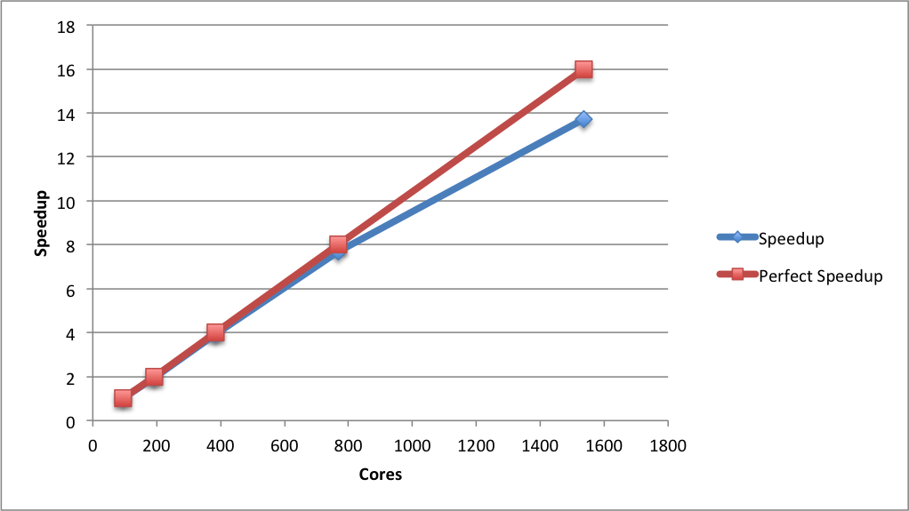
- Data Management and Transfer
This section asks some basic questions about the data generated on Tier-2 by the proposed calculations.
7.1 How many files are typically produced by each job?
[Enter the estimated number of files. This does not need to be exact, order of magnitude is sufficient here. For example, 1000 files per job. You should also state how these files are organised; for example, are they all stored in one directory or is there a hierarchy of directories?]
7.2 How much data is read in by each job?
[Enter estimated total size in kB/MB/GB/TB]
7.3 How much data is produced by each job?
[Enter estimated total size in GB/TB/PB]
7.4 What percentage of the produced data do you expect to transfer?
- To the centres storage facility? [Enter estimated percentage]
- Off Tier-2? [Enter estimated percentage]
7.5 How do you plan to transfer data from the Tier-2 centre to the (insert storage facility)?
[Please describe the mechanism by which you will move data from the Tier-2 centre to the centres storage facility. Will these transfers be manual or automated? You should also state roughly the amount of data that will be transferred in each transfer instance (i.e. how will the transfers be batched up).]
7.6 How do you plan to transfer data off Tier-2/Storage facility?
[Please describe the mechanism you will use to transfer data from Tier-2/storage facility to external sites for further analysis or archive. Please also state the sites that you will be transferring data to. You should also state roughly the amount of data that will be transferred in each transfer instance (i.e. how will the transfers be batched up).]

N.b. Applicants are responsible for ensuring copies of all data. The Tier-2 services are not liable for any data loss on the systems.
Section 2: Technical Assessment (To be completed by Tier-2 team).

Date Received by Tier-2 centre: [Enter received date]

Do the applicants have the technical expertise required for the proposed work? | Yes/No

Is the software specified technically suitable for the Tier-2 machine requested? | Yes/No

Is the compute time requested reasonable and has the job breakdown been technically justified? Are the storage requests reasonable? | Yes/No

Has scaling evidence been provide that shows speedup to required job size for the software specified? | Yes/No

Is the data management and transfer plan reasonable and technically sound? | Yes/No

Is the application, as outlined above, suitable for access to the Tier-2 service? Yes / No

Does the project require the technical capabilities of Tier-2?
Would a different computing resource be more appropriate? If so, which one?

Name: [Enter name]
Position: [Enter job title]
Date: [Enter date completed]

