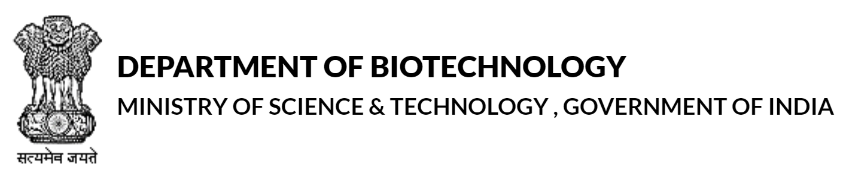

India-UK partnership to address farmed animal disease and health

Applicant List
Please provide the names, full affiliations and contact details of all principal and co-investigators. Please indicate the lead investigator from each country in bold font.

Country | Position | Name | Organisation | Department/Division | E-mail

