Contents of the Grey Box
PLEASE USE THIS LIST TO ENSURE THAT ALL ITEMS ARE IN THE CASE UPON BOTH RECEIPT AND RETURN
School……………………………………………….. Signed……………………………………….. Date…………………. Print name…………………………………….
 | Item | Image | In box on arrival  (date) | In box on return (date) |  | Item | Image | In box on arrival  (date) | In box on return (date)
1 | Disk of lunar rock and soil  Number 231 | 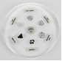 |  |  | 7 | Carbonaceous chondrite slice (encapsulated) | 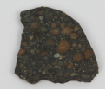
2 | Moldavite impactite  (encapsulated) | 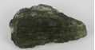 |  |  | 8 | 5 x magnaprobes | 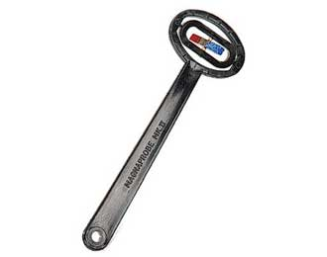
3 | Lunar meteorite (encapsulated) | 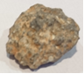 |  |  | 9 | 10 x handlenses | 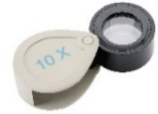
4 | Imilac pallasite (encapsulated) | 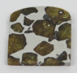 |  |  | 10 | Item removed from set
5 | Etched iron meteorite slice (encapsulated) | 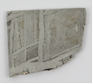 |  |  | 11 | Anorthosite – Lunar analogue | 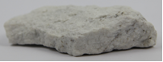
6 | Martian meteorite (encapsulated) | 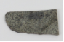 |  |  | 12 | Cut and polished Sahara chondrite | 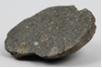
13 | Sahara chondrite meteorite | 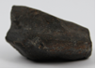 |  |  | 22 | 4 x clamps | 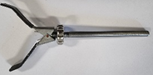
14 | Basalt – Lunar analogue | 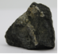 |  |  | 23 | 4 x bosses | 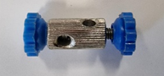
15 | Tektite impactite | 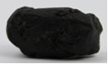 |  |  | 24 | 4 x usb microsopes | 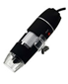
16 | Lybian glass impactite | 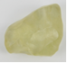 |  |  | 25 | 5 x Meteorite Hunter boxes | 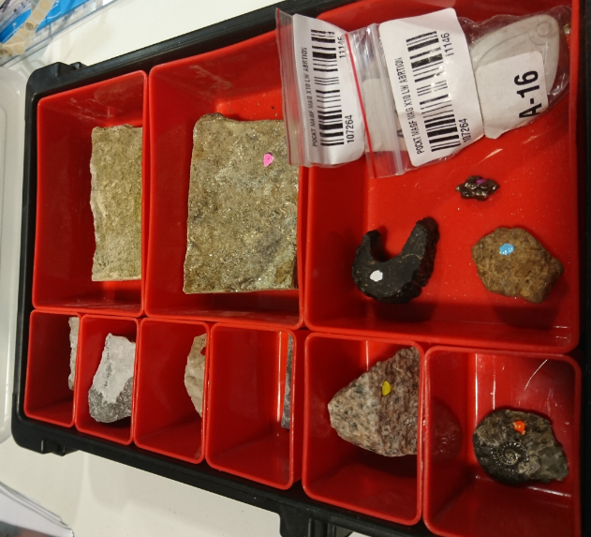
17 | Udei station iron meteorite | 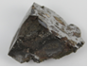 |  |  | 26 | Teachers Guide | 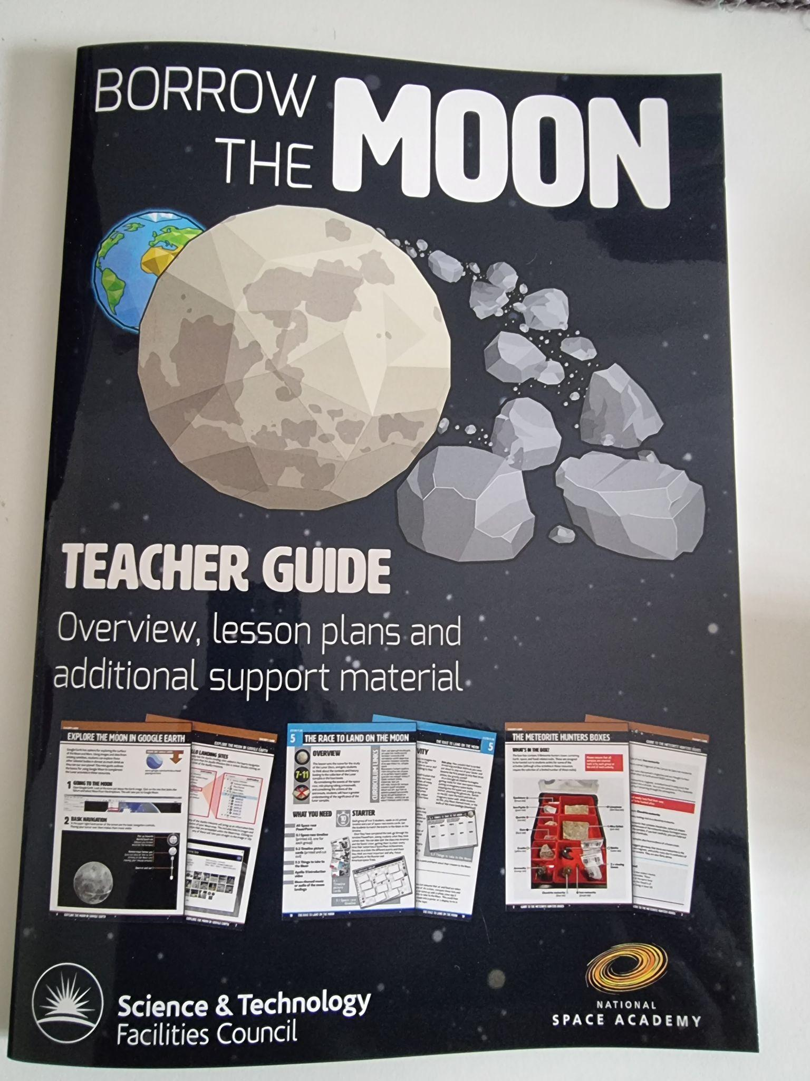
18 | Large Campo de Cielo iron meteorite | 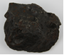 |  |  | 27 | NHM Meteorites book | 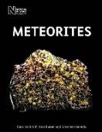
19 | 4 x clamp bases | 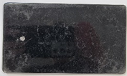 |  |  | 28 | 1 x Phillips Moon Map | 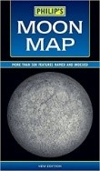
20 | 4 x rods | 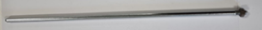 |  |  | 29 | Checklist folder & sheets | 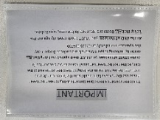
21 | Scales | 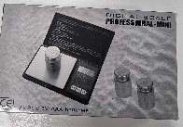 |  |  |  | Notes

