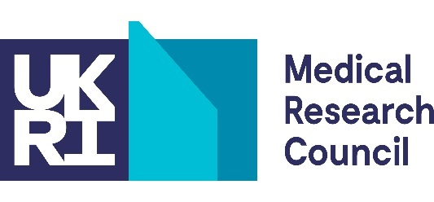
Our Future Health Data Access Scheme: Expression of Interest

Please check Our Future Health’s requirements for researcher registration and study applications before submitting this form.
Your details
Your name
Email address (institutional)
Phone number
Organisation
Division or department

If applying on behalf of a student or fellow

Name of student/fellow
Job title/role
Email address (institutional)
Organisation
Division or department

MRC funding This must be current to be eligible for this scheme
MRC project or grant reference number
Other identifying information, if necessary
Principal investigator
Organisation
Division or department
Research co funder, if appropriate

Your proposed research
Title
Likely duration (we expect projects to be 1–2 years in duration)
Explain the study aim and scientific rationale for your proposed research (up to 600 words in total). You can use the same information on your study application to Our Future Health. You can include the background to the proposal and relevant references (for example, as PubMed PMIDs or Digital Object Identifiers (DOIs).
Describe how your proposed research aligns with your current MRC-funded research (up to 200 words).
Describe how your proposed research aligns with MRC-funded priorities
(up to 200 words).
Describe how the findings from your proposal will inform the development of ideas for future research (up to 200 words).
Have you previously applied to Our Future Health to access data? Yes No
If yes, was your application approved? Yes No

Information about data sharing between MRC and Our Future Health continues on the next page.

Please email your completed form to OFH@mrc.ukri.org
Compliance with the UK data protection legislation and the EU General Data Protection Regulations 2016/679 (GDPR)
In accordance with UK data protection legislation and the EU General Data Protection Regulations 2016/679 (GDPR), the personal data provided on this form will be processed by MRC, as part of UKRI, and may be held on computerised databases and/or manual files. Further details can be found on the UK Research and Innovation Privacy Notice (https://www.ukri.org/privacy-notice/).
Sharing data between MRC and Our Future Health
If eligibility is confirmed, we will share the following information with Our Future Health:
- your name and that of the student/fellow, where appropriate
- MRC project reference or other identifier
- the title and duration of proposed research
Our Future Health will share with MRC:
- the outcome of the study application process
- for approved studies, annual progress reports submitted to Our Future Health.
Any amendments to the study title or aims made by the researcher following access approval by OFH and notified to OFH may be shared with MRC. In addition, we may carry out spot checks to compare study applications to Our Future Health with the study plans described on the MRC Expression of Interest form. Therefore, you should expect that Our Future Health will share this information with us.

