UKRI Translation - Prosperity Partnerships 2027 – Partner Contributions to Costs – Table and Guidance

Mandatory – you are required to complete the costings table when submitting your application. Failure to do so will result in the rejection of your application.

The figure below summarises the match funding requirements.

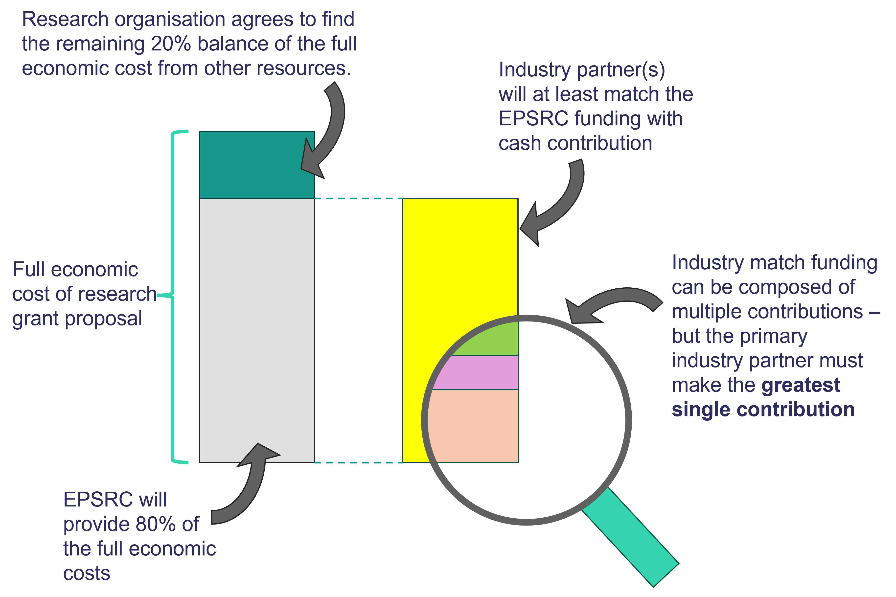
Complete the table to provide a breakdown of the match funding that you have secured from your project partners and paste it into your TFS application answer box (‘Partner contribution to costs’ section).

- All project partner cash contributions should be briefly described in the table below
- Full details of each project partner contribution should be provided separately in the corresponding project partner letter (or email) of support
- Contributions without a corresponding letter of support will be removed
- Our definitive list of “cash contributions” can be found in the section “What we are looking for”
- Use the Transparent Approach to Costing (TRAC) methodology
- Do not apply indexation to the funds requested from EPSRC– this will be done by UKRI
- The combined cash contributions from all the business partners must at least match the EPSRC funding requested.
- The value of the primary business partner’s cash contribution must be the greatest among business partners on this application
The following values A-M should be determined and input to the table below:

Cash Contributions:
- A: Full economic cost (100% FEC) of project costs (excludes business partner(s) contribution(s), use the Transparent Approach to Costing (TRAC) methodology)
- B: Value of funding being requested from EPSRC at 80% FEC (80% of full economic cost, value A)
- C: Primary business partner’s cash contribution
- D: Where applicable, other non-primary business partners’ cash contributions (each partner should be on a separate row. Add additional rows as required. Use D1, D2, D3 etc. to separately denote non-primary business partners)
  - Check that the sum of the business partner contributions (C+D) is greater than or equal to the 80% FEC value of funding being requested from EPSRC (B)
  - Check that value C is the greatest single value from all business partners
- E: Where applicable, primary academic partner’s cash contribution, excluding the standard 20% of FEC (note that in this opportunity, cash contributions from the academic partners are not required and do not count towards the minimum match funding requirement)
- F: Where applicable, other academic partner’s cash contributions (each partner should be on a separate row. Add additional rows as required. Use F1, F2, F3 etc. to separately denote non-primary academic partners)
- G: Combined project cash value (A+C+D+E+F)

In Kind Contributions:
- H: Primary Business Partner in-kind contributions
- I: Non-primary business partners’ in-kind contributions (add as many rows as you need. Use I1, I2, I3 etc. to separately denote non-primary business partners)
- J: Primary Academic Partner in-kind contributions
- K: Non-primary academic partner’s in-kind contributions (add as many rows as you need. Use K1, K2, K3 etc. to separately denote non-primary academic partners)
- L: Sum of all in-kind contributions

Combined project value
- M: Combines full economic costs, cash and in-kind value (excludes EPSRC funding requested, G+L)

Row label | Category Description | Contributing Organisation | Value | Description
A | Full economic cost of requested project funding | N/A |  | Provide details in the section “Resources and Cost Justification”
B | EPSRC funding requested | EPSRC |  | 80% of A
C | Primary Business Partner cash contribution | Primary Business Partner name |  | Brief description, see letter of support for breakdown
D | Non-primary business partners’ cash contribution (add as many rows as you need) | Non-primary business partner name |  | Brief description, see letter of support for breakdown
E | Primary Academic partner’s cash contribution | Primary Academic partner name |  | Brief description, see letter of support for breakdown
F | Non-primary academic partner’s cash contributions  (add as many rows as you need) | Non-primary academic partner name |  | Brief description, see letter of support for breakdown
G | Combined project cash value | A+C+D+E+F
H | Primary Business Partner in-kind contributions | Primary Business Partner name |  | Brief description, see letter of support for breakdown
I | Non-primary business partners’ in-kind contributions (add as many rows as you need) | Non-primary business partner name |  | Brief description, see letter of support for breakdown
J | Primary Academic Partner in-kind contributions | Primary Academic Partner name |  | Brief description, see letter of support for breakdown
K | Non-primary academic partner’s in-kind contributions (add as many rows as you need) | Non-primary academic Partner name |  | Brief description, see letter of support for breakdown
L | Combined project in-kind value | H+I+J+K
M | Combined project value (cash + in-kind) | G+L

Definitive list of eligible cash contributions
Please note that the names of grant roles have changed.
Researchers’ salaries (including project co-lead, researcher co-lead)
This should be all or part of the pro-rata, gross salary cost associated with researchers employed by universities or businesses (including co-leads, and postgraduate research assistants). The expectation is that researchers will devote a significant and appropriate amount of their time on the Prosperity Partnership required for the project. This will be one of the aspects looked at by peer review to ensure that the appropriate resources are being dedicated to the project.
Research and innovation associates’ salary (including postdoctoral research associates)
This should be all or part of the gross salary cost associated with research and innovation associates employed by research organisations to work exclusively on the Prosperity Partnership. Research and innovation associates can also be employed directly by the businesses in the partnership and claim the gross salary as a cash contribution if they are exclusively committed to working on the Prosperity Partnership.
Professional enabling staff salary (including grant manager)
The pro-rata gross salary cost of professional enabling staff is an eligible cash contribution. The expectation is that they will devote a significant and appropriate amount of their time on the Prosperity Partnership required for the project.
Specialists’ and technicians’ salary
The pro-rata gross salary costs of specialists are an eligible cash contribution. A specialist is an individual who brings specialist skills and intellectual input to the project. For example, data scientist, graphic designer, high-level or specialist technician or librarian. They must be employed by the primary business partner or one of the collaborating partners and the expectation is that they will devote a significant and appropriate amount of their time on the Prosperity Partnership required for the project.
Software licences
This should be new software licences needed for the project and their maintenance cost for the duration of the grant. Software licences or intellectual property owned by the business which are already accessible by the partners will apply at marginal cost, not at market rate.
New equipment
This should be genuine new equipment purchases and should be dedicated to the objectives of the Prosperity Partnership, and their utilisation should be critical to deliver the activity. The access does not have to be restricted to the project members, but EPSRC expects that the equipment will be available to project members as required for the project. All equipment should be appropriately justified.

Equipment produced by the business
This should be equipment produced by the business, but only at the cost of manufacture, not market rate.

Equipment-specific materials
This should be specific consumable materials which are required for certain equipment, for example material used in 3D-printing.
Access to equipment and facilities
This should be access to specific equipment and facilities critical to achieve the outcomes of the project (including access to labs and use of lab equipment). If the facility is based at the academic or primary business partner, the contribution will be at the internal rate, not market rate.
Facilities refurbishment
Facilities refurbishment can be an eligible research organisation cash contribution if the upgrade will increase the capability of the facilities. This contribution must be justified in addition to any estate costs already factored in.
Business cash donation
This is a business cash donation which will be provided to the partner universities, for the universities to manage in line with the project objectives.

Budget examples and eligible cash contributions

Example case 1 (partnership between a university and a single business, with additional public sector partners)

An example partnership is applying to support a 4-year project involving one university and one business partner. The project also includes a public sector partner that will be making an in-kind contribution to the project.

- The full economic cost (FEC) of the project is £2,000,000.
- EPSRC contribution at 80% FEC = £1,600,000. The primary academic partner provides the remaining 20% of FEC = £400,000 from other sources, as is typical for applications costed on the basis of full economic costs.
- Minimum cash contribution from the sole business partner = £1,600,000
- The primary business partner must at least match EPSRC’s contribution with eligible cash contributions. In this specific example, as there are no other business partners involved, the primary business partner’s contribution is at least £1,600,000.
- The primary academic lead may contribute with additional cash or in-kind contributions however they will not count towards the matching contribution. Do not record the 20% contribution to FEC here.
- Public sector organisations can be project partners and may contribute cash or in-kind. Record them as “non-primary business partners”. Note that public sector contributions will not count towards the matching contribution.

Row label | Category Description | Contributing Organisation | Value of Contribution | Description
A | Full economic cost of requested project funding | N/A | £2,000,000 | See “Resources and Cost Justification”
B | EPSRC funding requested | EPSRC | £1,600,000 | 80% of A
C | Primary Business Partner cash contribution | Primary Business Partner name | £1,600,000 | Staff and researcher salaries, cash donation and equipment. See letter of support for breakdown.
D | Non-primary business partners’ cash contribution (add as many rows as you need) | Non-primary business partner name | N/A | N/A
E | Primary Academic partner’s cash contribution | Primary Academic partner name | £0 | None
F | Non-primary academic partner’s cash contributions  (add as many rows as you need) | Non-primary academic partner name | N/A | N/A
G | Combined project cash value | £3,600,000
H | Primary Business Partner in-kind contributions | Primary Business Partner name | £500,000 | Staff time, see letter of support for breakdown
I | Non-primary business partners’ in-kind contributions (add as many rows as you need) | Example Public sector organisation | £400,000 | Access to dataset
J | Primary Academic Partner in-kind contributions | Primary Academic Partner name | £0 | None
K | Non-primary academic partner’s in-kind contributions (add as many rows as you need) | Non-primary academic Partner name | N/A | N/A
L | Combined project in-kind value | £900,000
M | Combined project value (cash + in-kind) | £4,500,000

Example case 2 (partnership involving multiple academic and business partners)
An example partnership is applying for a 5-year project involving a primary academic and primary business partner, as well as several non-primary academic and business partners. Some of the non-primary business partners are contributing towards the match funding requirement.

- The full economic cost (FEC) of the project is £4,000,000.
- EPSRC contribution at 80% FEC = £3,200,000. The primary academic partner provides the remaining 20% of FEC = £800,000 from other sources, as is typical for applications costed on the basis of full economic costs.
- The primary business partner must make the largest single contribution. In this case they contribute £2,000,000
- Other business partners contribute towards the minimum match funding requirement of £3,200,000 with eligible cash contributions.
- The non-primary business partners collectively contribute £1,200,000
- The primary academic lead may contribute with additional cash or in-kind contributions however they will not count towards the matching contribution. Do not record the 20% contribution to FEC here.
- Other academic partners may also contribute cash or in-kind. Again, does not count towards the match funding requirement.

Row label | Category Description | Contributing Organisation | Value | Description
A | Full economic cost of requested project funding | N/A | £4,000,000 | See “Resources and Cost Justification”
B | EPSRC funding requested | EPSRC | £3,200,000 | 80% of A
C | Primary Business Partner cash contribution | Primary Business Partner name | £2,000,000 | Project manager salary, researcher and specialist salaries, cash donation. See letter of support for breakdown
D1 | Non-primary business partners’ cash contribution (add as many rows as you need) | Example non-primary company 1 | £800,000 | Cash donation, see letter of support for breakdown
D2 | ... | Example non-primary company 2 | £400,000 | Critical equipment provided to project at cost. See letter of support for breakdown
D3 | ... | Example non-primary company 3 | £0 | In-kind only.
E | Primary Academic partner’s cash contribution | Primary Academic partner name | £150,000 | Studentship, see primary academic partner research organisation statement for breakdown.
F1 | Non-primary academic partner’s cash contributions  (add as many rows as you need) | Example non-primary academic partner 1 | £300,000 | 2x Studentships, see primary academic partner research organisation statement for breakdown.
F2 | ... | Example non-primary academic partner 2 | £50,000 | Technician salary, see letter of support for breakdown.
F2 | ...
G | Combined project cash value | £7,700,000
H | Primary Business Partner in-kind contributions | Primary Business Partner name | £50,000 | Computational resources, see letter of support for breakdown
D1 | Non-primary business partners’ in-kind contribution (add as many rows as you need) | Example non-primary company 1 | £180,000 | Cloud computing credits, see letter of support for breakdown
D2 | ... | Example non-primary company 2 | £0 | Cash only
D3 | ... | Example non-primary company 3 | £400,000 | Staff time, see letter of support for breakdown
J | Primary Academic Partner in-kind contributions | Primary Academic Partner name | £100,000 | Staff time, see primary academic partner research organisation statement for breakdown
K1 | Non-primary academic partner’s in-kind contribution  (add as many rows as you need) | Example non-primary academic partner 1 | £0 | Cash only, see letter of support for breakdown
K2 | ... | Example non-primary academic partner 2 | £0 | Cash only, see letter of support for breakdown
L | Combined project in-kind value | £730,000
M | Combined project value (cash + in-kind) | £8,430,000

