STFC Ernest Rutherford Fellowships (ERF)

HOST INSTITUTION ED&I STATEMENT

The intention of this statement is to better understand the process by which host institutions are selecting candidates and to identify examples of best practice.

People are at the core of research and innovation and there is nothing more important than how we attract, develop, and retain talented people to cement our position as a global science superpower. Including and valuing a broader range of people and talent will help us achieve the extraordinary potential of research and innovation.

Please complete the survey to include details about the inclusivity of your host institution ERF candidate selection processes using the link or QR code below. Please also include any recruitment strategies your institution use and provide us with insight to any innovative processes you use in your selection process.

https://app.onlinesurveys.jisc.ac.uk/s/stfc/stfc-ernest-rutherford-fellowships-ed-i-statement-duplicate



Submissions should provide sufficient detail for assessment.

This statement is mandatory and any Ernest Rutherford Fellowship applications that are submitted from a Research Organisation that has either failed to submit or submitted an inadequate ED&I statement will not be considered until an adequate statement has been received.

ED&I Statements will be assessed by a sub-panel of the Education, Training and Careers Committee (ETCC) to ensure satisfactory processes are in place. Details of the assessment criteria to be used can be found at Annex 1 and are intended to promote a fair, transparent, and consistent evaluation of how host organisations support Ernest Rutherford Fellowship applicants.

Statements will be assessed in November 2026 with confirmation of outcomes provided no later than December 2026. The outcome of the assessment will have no bearing of how applicants are scored, unless an inadequate score for the ED&I statement is given, as noted above.

The deadline for submitting responses will be 30 September 2026.

Best practice example of an inclusive selection practice

The two diagrams below represent an example of best practice for recruitment and selection process for ERF applications within a host organisation. The first shows the overall recruitment and selection process, while the second focuses on the selection part within that. Please note that STFC are not looking at host organisations carrying out an anonymised practice.

Overall process

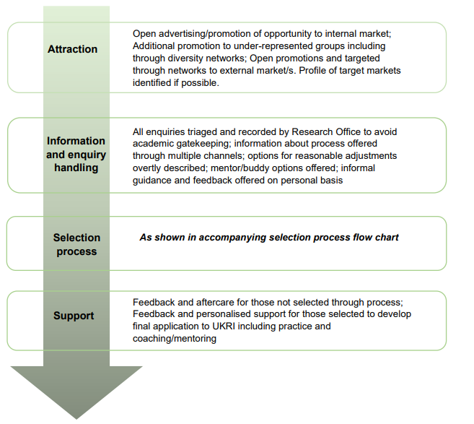

Selection process

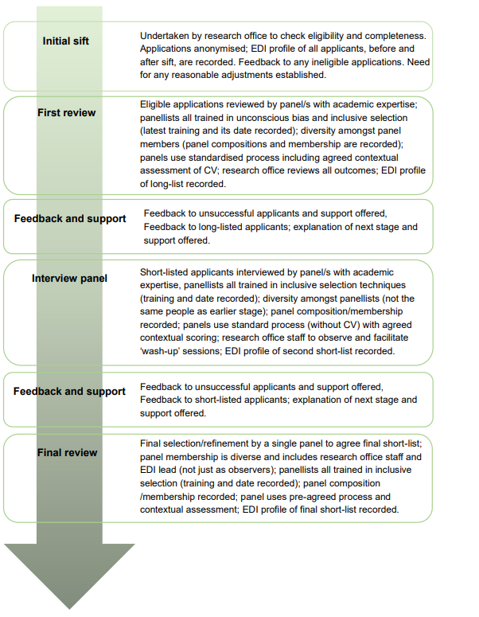

Please find in the table below a list of the questions in the survey (https://app.onlinesurveys.jisc.ac.uk/s/stfc/stfc-ernest-rutherford-fellowships-ed-i-statement-duplicate) along with examples of good practice

Questions | Examples of good practice but not limited to:
Attraction
How was the ERF opportunity advertised/promoted internally, nationally and internationally? How did you encourage diverse applicants? | - Use of academic staff networks and diversity networks  - Websites  - Inspire  - Social media  - Offering workshops to help prospective candidates develop strong Expressions of Interest.  - Fellowship and funding opportunity awareness sessions  - Use of clear, neutral, and inclusive language that welcomes individuals from underrepresented groups and avoids creating barriers or discouraging participation.
Information and enquiry handling
How were enquiries handled, and process information offered? | - Use of research office to triage and record enquiries to avoid academic gatekeeping.  - Information offered through different channels i.e. mentor/buddy options, informal guidance and feedback on a personal basis, information on options for reasonable adjustments.
Selection process
How was the initial sift carried out? | - Use of research office to carry out eligibility and completeness checks.  - Use of a centralised approach in larger host organisations to ensure coherence and consistency across diverse disciplines.  - Recording EDI profile of all applicants before and after initial sift.  - Establishing any needs for reasonable adjustments acknowledging personal circumstances of applicants.  - Providing feedback to any ineligible applicants.
Please provide examples of how applicants were supported through the internal selection process? | - Assign research staff mentor with mentor matched to expertise.  - Assignment of administrative/costing support.  - One to one feedback offered to every candidate.  - Applicants encouraged to make links within the group.  - Grant writing support/workshops.
What support or consideration of flexible working including part-time working, career breaks and caring responsibilities will you give, and will you accommodate inclusion of candidates with different career paths? | - Consideration given to range of technologies to stay connected  - Have guidance to adjust criteria to assess career breaks / caring responsibilities. Assessed separately and adjustment agreed by two independent members of panel.  - Advice given to candidates on flexible working arrangements  - Support provided through maternity/adoption/shared parental leave  - Keeping in touch days during leave  - ED&I newsletter featuring part time staff  - Childcare support
How are applications reviewed? | - Applications are assessed by panel/s with appropriate academic expertise.  - All panel members are trained in unconscious bias and inclusive selection processes.  - Diversity amongst panel members with panel composition recorded.  - The panel uses a standardised process including an agreed assessment of applicants against the ERF Assessment Criteria.
Interview Panel
How have you ensured that interview panels are diverse and follow a standardised process? | - Short-listed applicants are interviewed by panels with the appropriate expertise.  - All panel members are trained in inclusive selection techniques.  - All protected characteristics are considered in panel member selection with panel composition recorded.  - Diversity in panel members through not using the same members as the review stage.  - Having a range of career stages represented in the panel.  - Panels follow a standardised process through assessment of applicant against the ERF assessment criteria.  - Use of research office observers to ensure no bias is introduced.
Feedback and Support
How is feedback and support provided to all applicants? | - Outcomes communicated promptly to every applicant.  - Feedback is provided to all unsuccessful applicants and support to apply for other, more suitable funding opportunities, is offered.  - Feedback is provided to short-listed applicants.  - Explanation of the next stage and support provided.
What support is provided to upskill research office staff and panel members? | - Informal sharing of knowledge in staff networks of the ERF scheme by more experienced colleagues, ensuring all applicants are supported with equal expertise.  - Inclusive recruitment and selection technique training.  - Diversity awareness and unconscious bias training for all staff.  - Data protection training.
Final Review
What processes were used to identify final candidates? | - Final short-list agreement made collectively by single panel to include Research Office and EDI lead.
Review and Improvement
How does the institution promote and take action to address equality at all levels and foster a more inclusive working environment? | - This could, for example, include the processes you adopt and/or holding of charter marks, such as Athena SWAN or Project Juno awards.
How does the institution promote a culture of continuous review and improvement? | For example, as per the Researcher Development Concordat:  - Undertake annual gap analyses of recruitment processes  - Agree and review recruitment process improvement actions through annual planning and reporting cycle to the institutions governing body  - Review applicant and panel feedback systematically  - Use external benchmarking (e.g. Vitae CEDARS survey, HR Excellence in Research Award, European Charter alignment, sector surveys)  - Use tools to support strategic planning on research culture, including recruitment (e.g., UKRI-Vitae Research Culture Framework)
Please tell us about any updates or improvements you have made to your selection processes this year.
Further information
Tell us about any examples of good practice you took to select candidates. | - Following guidance in internal or independent reports e.g. Equity and Inclusivity in Research Funding (ox.ac.uk)
How many applications / expressions of interest did you receive for the ERF in your institution?
Can you specify how many applicants were internal, external, and international detailing how successful they were in the process.
How many applicants were returning to research from a career break, and did they require additional support?

Data Collection at UKRI

When research organisations submit ERF applications to STFC, the Funding Service collects personal data including date of birth, ethnic origin, gender and disability. UKRI use this personal data to:

Inform analysis to investigate if applicants to the scheme who share a protected characteristic:

a. suffer a disadvantage linked to that characteristic
b. have different needs to other groups, or
c. have a disproportionately low level of participation

If this results in an evidenced need then STFC may make appropriate and proportionate interventions, including in final funding decisions. This is in accordance with STFCs duty to advance equality of opportunity between those who share a protected characteristic and those who do not.

Data collection at academic research organisations

As Higher Education Institutions have a responsibility under the Public Sector Equality Duty (PSED) to advance equality of opportunity, the collection and reporting of data at a scheme level will provide hosts with insights/evidence to demonstrate compliance with this duty alongside providing insights into how effective their current attraction and selection policies and procedures are. Data collection is an early and vital step in the process of designing initiatives to tackle issues related to inequality, checking that an initiative is having the desired effects and making changes to an initiative, if required.

CRAC - Identifying Good Practice Relating To Inclusive Selection Within The Future Leaders Fellowship Scheme

